Lost Asylum by Prosidha

**Genre:** Graphic horror, psychological thriller, puzzle-mystery  
**Setting:** Abandoned, fog-shrouded psychiatric asylum in the mountains, long forgotten by time.

**Prologue: Whispered Silence**

You are **Evelyn Gray**, a teenage girl drawn to a place no map marks anymore. A journal arrives in the mail—no return address. Its pages? Bloodstained. It belonged to your mother, who disappeared sixteen years ago. Her final words read:

"They erased us. The asylum was never shut down. It sank into itself."

Driven by that journal, you return to the place she once worked: **Violet Hill Asylum**, officially closed in 1972. But records show it operated long after that, beneath the surface—literally and figuratively.

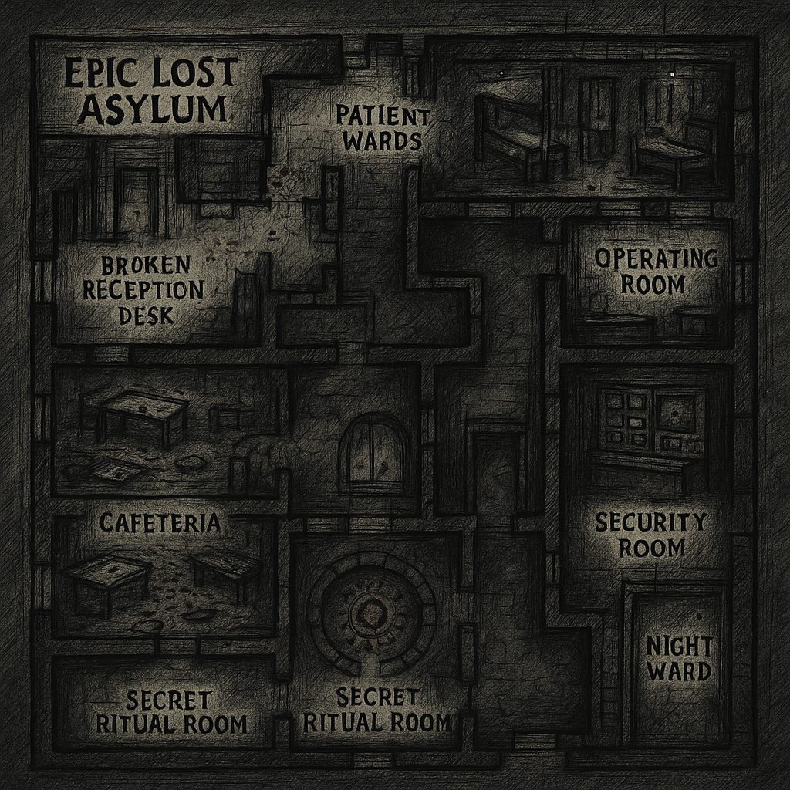

*Character sketch

* Evelyn Gray – The Seeker

Age: 17  
Role: Protagonist  
Appearance: Pale skin, dark hoodie, silver locket with a faded photo of her mother. Eyes always scanning.  
Personality: Quiet but relentless. Her curiosity masks a deep fear of being forgotten. Haunted by half-memories of lullabies that never existed.  
Backstory: Never knew her mother well. Found her diary a week before the first nightmare. Feels a pull to the asylum like it’s calling her home. Dr. Alaric Vane – The Whispering Doctor

Age: ??? (once 47)  
Role: Former head psychiatrist of the asylum  
Appearance: Hollow eyes, always wearing a bloodstained white coat. Never walks—he floats, silent, unless he wants you to hear him.  
Personality: Calm, precise, unnervingly polite. Speaks as if reading from a medical report.  
Backstory: Believed consciousness could be “peeled” into layers. Performed unsanctioned experiments in the Night Ward.  
Power: Appears in mirrors or through static. Can alter room layouts.

**Clara "The Doll" Mirelle – *Patient #042***

**Age:** Appears 8  
**Role:** Echo of a lost child  
**Appearance:** Wears a torn lace dress. Porcelain mask stitched to her face. Eyes move independently of her head.  
**Personality:** Innocent, but not harmless. Repeats phrases like a broken toy.  
**Backstory:** Said to be the daughter of a nurse. Disappeared during a lockdown. Her drawings cover entire asylum walls. Some are of *you*.  
**Mechanic:** Leads you to secret passageways… but sometimes to death.

Mother Gray (Unknown Name) – The Vanished Voice

Age: Early 30s (last seen)  
Role: Evelyn’s mother  
Appearance: Shadowy figure in a hospital gown, long hair covering her face. Whispers lullabies from behind locked doors.  
Personality: Fragmented. Sometimes warm, sometimes violently protective.  
Backstory: Once a nurse at the asylum. Tried to expose its secrets. May have merged with the “Whisperer.”  
Mechanic: Only appears in dreams or flashbacks—unless you unlock the final ritual doo

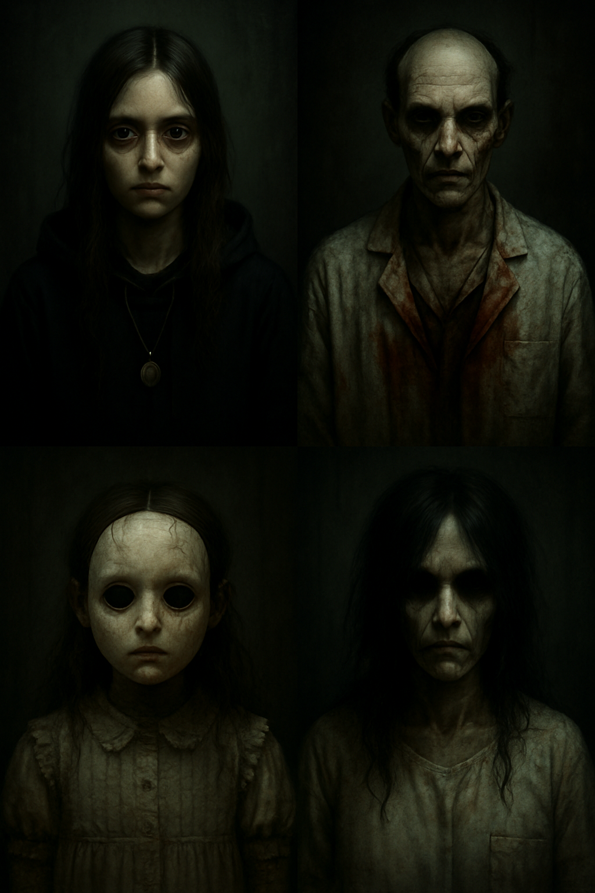

**Chapter I: The Arrival**

You enter the grounds. The gates close behind you. You cannot leave. A dense fog surrounds the asylum, and **the sky never changes**. The building breathes, creaks like it's alive. Paint peels like dead skin.  
You find cryptic notes from former patients, faded photographs, and **a child’s drawing of a shadow with too many eyes.**

**Gameplay:**

Search for items and keys

Solve puzzles involving old therapy rooms

Read patient files that don't match any known psychology

**Chapter II: The Unreliable Mind**

As you descend deeper—into sealed wings and locked basements—**your surroundings shift**. Doors appear and vanish. Rooms repeat themselves but with minor, disturbing changes. You hear weeping in the walls. You start to see a woman in a hospital gown—her face is yours.

**Twist:** Your mother might not have vanished. She might still be here. Or perhaps... she *became* the asylum.

**Chapter III: The Other Patients**

You begin to encounter **shadows**—not enemies, but fractured memories. Each one presents a puzzle or mini-story:

A nurse who tried to free the patients but became one herself

A little boy who believes the moon is trapped inside the building

A silent pianist who only plays backwards, summoning a hallway that never existed

These memories give you pieces of a **broken key**—to unlock the "Night Ward."

**Chapter IV: The Night Ward**

Behind the Night Ward’s sealed door lies the *origin*—a circular room of ancient stone beneath the asylum. This isn't just a hospital; it was built atop a **pre-human ritual site**, where minds were unraveled to reveal what's behind thought itself.

You confront **"The Whisperer"**, a being of collective madness, formed from the minds of the patients and staff who disappeared.

**Final Puzzle/Battle:**  
You must choose to:

**Merge** with the asylum, controlling it from within to prevent its spread.

**Destroy** it and erase the memories of your mother—and yourself.

**Forget** everything and leave, pretending none of it happened... but the gate remains open.

**Epilogue:**

Depending on your choice, the ending changes:

*Control Ending:* You become the new voice in the journal.

*Destruction Ending:* The asylum crumbles, and your screen goes black forever—no credits.

*Forget Ending:* The game restarts like nothing happened—but the menu background is subtly different… and someone else is knocking on the gate.

**Chapter V: The Dollmaker’s Nest**

**“Silence is the final lullaby.”**

The door to the Night Ward groaned shut behind Clara, but this time, it didn’t echo—it *breathed*. A low inhale through the pitch-black halls that exhaled into her spine. Dust swirled like ash in the beam of her flickering torch. Ahead, a corridor wound like a serpent, and at its end… laughter.

Not a child’s giggle, no. It was *wet*, like porcelain cracking under water, and it came from every direction at once.

Pinned to the walls were dolls—hundreds—each with red thread sewn across their lips and buttons where eyes should have been. Some had scalpel-carved smiles. Some still twitched.

In the centre of the ward stood a great wooden door, carved with a phrase in Latin:

**“Tacete. In silentio, Salus.”**  
*(Be silent. In silence, salvation.)*

Inside that room—Room 27—sat a rocking chair, rocking without wind. A mobile spun above it, made from teeth and rusted scalpels.

Then came *his* voice.

A lullaby. Crooked. Shattered. Sung by someone who hadn’t drawn breath in years.

**Chapter VI: The Hydrotherapy Depths**

*“Some sins cannot be drowned.”*  
Clara descends to the sub-basement, where rusted water pipes weep and tanks used for 'hydrotherapy' overflow with stagnant, black water. The ghost of **Warden Hale** prowls here, his drowned form whispering therapy instructions between screams. Clara must shut down the old filtration system—but the valves are beneath the water, and something is watching from below.

**Chapter VII: The Siren of Ward 9**

*“Her lullaby brings coma. Her kiss brings death.”*  
This forbidden wing was once for catatonic patients. Here Clara meets **The Siren**, a patient who never spoke—until her coma turned into song. Her voice can shatter glass and memory alike. Clara must solve audio-based puzzles while navigating a sound-sensitive environment where every footstep might mean her end.

**Chapter VIII: The Clockwork Morgue**

*“Time can’t heal all wounds. It just preserves them.”*  
A forgotten wing built into the old morgue, where time loops endlessly. Clocks tick in reverse. Corpses speak backwards. Clara is trapped in a day that restarts every time she dies. She must uncover the correct timeline order by reliving fragments of the past… over and over again.

**Chapter IX: The Orphan's Choir**

*“They sang for help. No one listened.”*  
The sound of children's voices leads Clara to an abandoned chapel beneath the east wing. Dozens of child apparitions perform a haunting chant that never ends. A ghostly conductor (a former music teacher) forces their spirits to perform eternally. Clara must sabotage the cursed organ and set them free—before they invite her to “join the choir.”

**Chapter X: The Eyeless Watchers**

*“They cannot see. Yet they see too much.”*  
In a wing with no lights, Clara must move in absolute darkness, guided only by whispers and heartbeat. Eyeless patients crawl along walls and ceilings. When Clara’s light flickers, they freeze—when it dies, they move. A terror of stealth and sound, where every breath may give her away.

**Chapter XI: The Mirror Labyrinth**

*“It’s not you on the other side.”*  
Clara stumbles into a hallway of two-way mirrors. But her reflection begins to move on its own… and eventually steps out. A doppelgänger—*Reflector Clara*—hunts her through a shifting mirror maze. Clara must find her real self again… before the copy replaces her permanently.

**Chapter XII: The Feast of Crows**

*“They ate their memories. Now they want yours.”*  
The cafeteria is grotesquely frozen in a banquet scene. Former orderlies and patients are seated, rotting but “alive,” forced to dine endlessly. Clara must impersonate a ghostly dinner guest to gather keys and clues while avoiding the **Butcher Nurse**, who serves “fresh minds” to the table.

**Chapter XIII: The Ink heart Archives**

*“Words write themselves in this place.”*  
A library of forgotten files, where the pages change when read aloud. Clara’s own history begins rewriting itself. She discovers files that suggest she *was* a patient here… or is being made into one. The player must solve narrative-based puzzles, choosing which truths to “believe” and which to erase—shaping the game’s ending.

**Chapter XIV: The Hall of Sleeping Saints**

*“They never woke up. Now they dream with eyes open.”*  
A former coma ward. Patients stand in rows, eyes open but minds locked in endless dreams. Clara must enter their shared dreamscape using an ancient neural device. Inside, nothing follows logic. Time folds, walls bleed poetry, and Clara learns what *really happened* the night the asylum fell.

**Chapter XV: The Heart of the Asylum**

*“Everything ends where it began.”*  
All doors lead to a single, pulsing chamber beneath the asylum: the original surgical theatre. The heartbeat Clara hears is real—a grotesque, stitched organ that powers the asylum itself. It’s been feeding on trauma. On memory. On *her*.  
The final choice must be made:

* Destroy the asylum, along with all trapped souls—including her own.
* Or… take the Dollmaker’s place and become the next Warden of Silence.

**Chapter XVI: The Marionette’s Cathedral**

*“Who pulls your strings, Clara?”*  
Deep beneath the Heart of the Asylum lies a ruined cathedral where puppet-strings hang from vaulted ceilings like spider silk. Shadows twitch above, guided by unseen hands. Clara finds herself manipulated—literally—by a force that bends her limbs with invisible thread. To move freely, she must sever her “puppeteer” in the rafters: an ancient entity known only as *The Seamstress*.

**Chapter XVII: The Scarlet Nursery**

*“Every cradle holds a scream.”*  
Clara stumbles into a locked ward that once cared for infants born in the asylum. But here, the toys cry and the cribs creak with invisible weight. She must navigate rooms where the environment reverts to a childlike, twisted dreamscape. Her memories of childhood—false or real—bleed into the world, forcing her to confront *what she lost before she arrived*.

**Chapter XVIII: The Spine Garden**

*“Bones bloom here.”*  
Once an open-air courtyard, it’s now overgrown with pale roots that grow from the bones of former patients. Trees groan with hanging spines like wind chimes. A patient known as the *Gardener* speaks in riddles, watering the bone-flowers with blood. Clara must piece together a puzzle from vertebrae, planting the truth to grow a “key” to the next gate.

**Chapter XIX: The Forgotten Clinic**

*“Diagnosis: non-existent.”*  
This wing never existed on any blueprint, and yet it is real. A liminal space of white noise and blank charts. Here, records flicker between patients Clara has met… and *her own name in every file*. She meets a silent psychiatrist in a mask of stitched mouths. Clara must undergo a false therapy session, navigating psychological dialogue trees—each decision affects the next chapter’s layout.

**Chapter XX: The Feast of Echoes**

*“Every scream leaves behind a taste.”*  
The cafeteria has changed again. This time, it’s a grand hall of gold chandeliers and opulence—but the guests are invisible. Only their teeth remain, clinking against silverware. Clara must collect fragments of past screams trapped in cutlery, reliving micro-memories that explain why the asylum truly fell. Among them: her own, suppressed cries.

**Chapter XXI: The Theatre of Stillness**

*“They applauded their own silence.”*  
In an old performance hall, Clara finds mannequins seated in rows, eternally watching a frozen stage. She is forced to reenact roles from the asylum’s history—nurse, patient, warden—each performance unlocking deeper truths about her past. But one mannequin *moves* when her back is turned. If she forgets her line… it stands.

**Chapter XXII: The Anatomy of God**

*“The body is a church. This one is broken.”*  
She enters a grotesque chapel where stained-glass windows depict surgical dissections. In the altar lies a massive sculpture—half human, half machine, pierced with scalpels like thorns. It pulses. Breathes. Clara must navigate this breathing level like a living organism, dodging contractions and bile, to retrieve the asylum’s original blueprint—hidden in a calcified heart.

**Chapter XXIII: The Lantern maker’s Wing**

*“He bottled souls in glass and called them ‘light.’”*  
The lanterns in the asylum burn without oil… and now she knows why. In this wing, Clara meets **The Lantern maker**, a once-beloved janitor turned occultist, who traps soul fragments in glowing jars. He offers Clara a deal: freedom, in exchange for one precious memory. The player must choose which memory to part with—affecting the final chapters’ ending.

**Chapter XXIV: The Velvet Guillotine**

*“Some minds are too sharp to be left uncut.”*  
This chamber of red drapes and echoing shears was once a behavioral correction ward. Clara is stalked by scissors with legs, the remains of a treatment machine gone rogue. To escape, she must snip loose threads from her own psyche—sacrificing skills or memories in gameplay to avoid being “trimmed.” Some choices are permanent.

**Chapter XXV: The Return to the First Bed**

*“Sleep, at last. But who wakes up?”*  
Clara returns to her starting room. Only now, it’s clear she never left. The walls have changed. Her reflection doesn’t match. Her *doll-self* sits at the bed, smiling. In this final chapter, the asylum collapses into a looping nightmare. Clara must face the final truth: **She created the asylum to hide from her trauma.**  
The asylum is her mind—and the patients are pieces of her.

The final choice:

* **Awaken:** Destroy the asylum and accept reality.
* **Forget:** Remain, ruling as the next Keeper of Silence.
* **Rewrite:** Fuse the memories and become a guardian of lost minds—neither patient nor saviour

**Chapter XXVI: The Archivist’s Spine**

“Every memory weighs something. That’s why we break.”  
The halls twist with giant, skeletal spines—shelves of bones, each vertebra labeled with names. Clara meets The Archivist, a fused beast of spine and sorrow, who demands she relive her five worst memories to pass. Each trial pulls her deeper into personal trauma, but also unlocks lost truths… including how she once volunteered at the asylum.

**Chapter XXVII: The Clock of Breaths**

“Time isn't measured in seconds. It’s in gasps.”  
Inside the Asylum's central clock tower, gears churn not to minutes but to exhalations. Each tick is a breath stolen from the sleeping. Clara must adjust time using stolen breath-capsules, but every time she alters the clock, another part of her disappears—memories, strength, kindness. She is becoming something less… or more.

**Chapter XXVIII: The Plaster Orchestra**

“Music without meaning is madness.”  
A soundproofed ward filled with headless mannequins holding instruments. A symphony of chaos. Clara must decipher a song composed from the screams of patients—each note a cry. Playing the full melody unlocks the path forward—but also reawakens buried despair within her. In the silence after the final note, she hears her mother's voice.

**Chapter XXIX: The Museum of Clara**

“They’ve been watching you. Forever.”  
She finds a hidden gallery: paintings, statues, video loops of herself, even as a child. How? Why? Each room is a twisted interpretation of her soul. A curator in porcelain robes offers her the role of “Exhibit.” If she refuses, the art attacks. She must burn the museum to escape—destroying beautiful lies.

**Chapter XXX: The Bone Cradle**

“To birth truth, something must die.”  
In the asylum’s birthing chamber lies a cocoon made of bone. Inside: a second Clara. Pale. Unformed. The Dollmaker tells her she was one of many, grown from memory and suffering. Clara must decide whether to merge with her twin—risking her selfhood—or destroy the clone and remain half-finished.

**Chapter XXXI: The Inkstone Oracle**

“Write your fate. But you must bleed to do so.”  
A chamber of black stone where prophecies are written in blood. Clara meets the Oracle, blind and stitched to the ceiling, who offers her a quill. She can rewrite her past—or peek at the ending. But every word she writes turns a part of her skin to ink. She leaves, covered in script, marked with her chosen fate.

**Chapter XXXII: The Womb of Silence**

“This is where the asylum was born.”  
The oldest room. A cell of stone and salt. Here, a mother once gave birth and died alone. The child became the first patient. Clara uncovers the secret: she is descended from the asylum's bloodline. It runs in her veins. She is not a visitor—she is its heir.

**Chapter XXXIII: The Salt Dolls’ Revolt**

“Even the obedient break.”  
The lifeless dolls in every room have awakened. Tired of being props. They now hunt wardens and patients alike. Clara must escape through a collapsing hallway as the asylum rebels against itself. Her choices across the game affect which dolls help or hinder her.

**Chapter XXXIV: The Sepulcher of Mirrors**

“You are your own grave.”  
Clara enters a silver crypt, where every mirror shows a death she hasn’t yet died. She must choose one reflection to embrace and live through it—each ending in her "death." But one reflection shows her living, older… free. She breaks that one, refusing it, and walks forward blind but defiant.

**Chapter XXXV: The Asylum in the Sky**

“Some dreams float too high.”  
She rises into the ethereal attic: floating beds, upside-down hallways, patient dreams suspended in mist. Clara walks through the final thoughts of the lost, collecting "dream threads" to weave into a key. As she opens the last door, a falling star cracks the dream, beginning the final collapse.

**Chapter XXXVI: The Reunion of Sins**

“You left them. They remember.”  
All characters she’s met return—some alive, some not. She walks through a purgatory dinner with all of them. Each confronts her with what she’s forgotten. The Siren sings a farewell. The Butcher Nurse apologizes. The Seamstress weeps. Clara must choose whom to save—only three can leave with her.

**Chapter XXXVII: The Door of Always**

“It was always locked from the inside.”  
The final door. Familiar. Clara now realizes she locked it herself. The door pulses with every name she's forgotten. To open it, she must say goodbye to everything: her name, her guilt, even the memory of who she is. The player must hit DELETE on her name manually. Only then does the door open.

**Chapter XXXVIII: The Last Daylight**

“It’s morning.”  
Clara steps into the ruins of the asylum, now exposed to daylight. Crows scatter. The fog lifts. There are flowers growing through the cracks. But the cost has been high. Only one friend made it out with her. The asylum vanishes in the sunlight like a dream denied.

**Chapter XXXIX: The Room of Remembering**

“Not all who forget are lost.”  
Clara builds a small wooden cabin, far from the city. Inside it, she places trinkets from the asylum—whispers of what was. She begins to paint again. Occasionally, she sees a patient in a dream, thanking her. Her memory is fractured… but peace is possible.

**Chapter XL: The Whisper Tree**

“In the end, even silence can sing.”  
One final walk through a blooming forest. A tree stands tall, its bark carved with names. Clara adds one last carving—her own, or someone else's. She smiles, though a tear runs down. As she steps away, the wind hums the lullaby from Chapter VII.

The screen fades to white. The game ends.

.